**Disease Prediction Systems for COVID with Electronic Medical Records**

**Senthilkumar G**, Associate professor, Department of CSE, Panimalar Engineering College

**Sasidhar V J,** U.G Scholar, Department of CSE, Panimalar Engineering College

**Saravana kumar S**, U.G Scholar, Department of CSE, Panimalar Engineering College

**Vignesh E**, U.G Scholar, Department of CSE, Panimalar Engineering College

***Abstract***

An electronic health record application which is used to extract patient’s information instantly and remotely .Also, It monitors the patient’s health performance and diagnose disease using machine learning algorithms. Conventionally, patient’s history is saved in the form of a prescription for necessary medications, streamline workflow, and to keep track of the patient’s performance in the paper chart containing the type of diseases, suggested medicines, vaccination dates, treatment plans, and the test results of X-rays specific hospitals. However, in the modern age of the computer, prescriptions are saved in digital format must be saved in a digital format to understand even better. Also, it reduces the burden for patients. t. So, our aim is to develop the mentioned idea above into an app which can be used by everyone.

**I INTRODUCTION**

Corona Virus (COVID-19) is an infectious disease caused by the severe acute respiratory syndrome called coronavirus

detected in December 2019 in Wuhan, China, and people are afraid of it since then given its mutation and long term effect in the patient’s medical condition so with this people can predict whether they have the Covid virus through uploading their X-ray chest scan. given the Medical issues surrounding the Reporting and Collection of data.

**II EXISTING SYSTEM**

Conventionally, patient’s history is saved in the form of a prescription for necessary medications, streamline workflow, and to keep track of the patient’s performance in the paper chart containing the type of diseases, suggested medicines, vaccination dates, treatment plans, and the test results of X-rays specific hospitals. They patients are also needed to maintain these prescription in time orderly manner for referring them in future and it takes some effort to manage them effectively while some records may go missing in the long run and even while visiting the doctor the patients need to carry them. So this proposed system can solve these problem with a modern solution for this Digital age.

**III PROPOSED SYSTEM**

The proposed system makes the user to manage their medical records efficiently in digital format which can be used for referring in the long run and it is non-volatile unlike the existing system which uses paper which gets torn or crushed during the years whereas the proposed system stores the records digitally and can be printed as hard copy as new and also can be preserved for many years without depletion in the quality of the records. Here we also included a covid disease prediction algorithm which predicts whether the patient has Covid with chest X-ray scan and patient can also book appointment with the doctor through this system and doctor can accept the appointment or he can reject them for a reschedule. Here the data are stored in cloud hence can be accessed from anywhere.

**IV SYSTEM ARCHITECTURE**

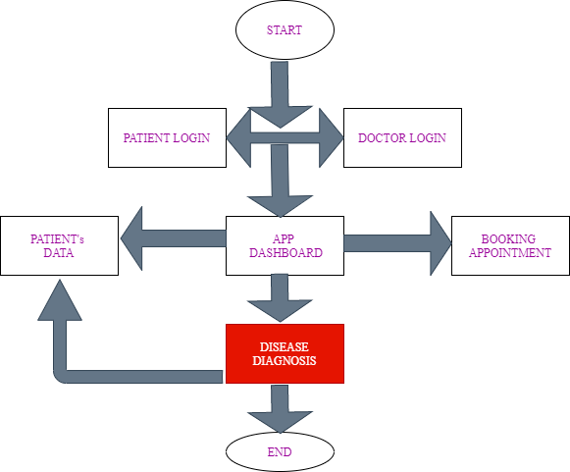

*Fig 1 : Architecture of the application*

The above figure shows the architecture of the app which functionalities have been mentioned for the better understanding of the application.

**V FEATURES OF THIS APP**

The app consists of two main modules, one for patient and other for Doctor. Each module is meant to interact with the database and display data in different formats.

**Register Patient user**

A register module is used to create users with email and password along with their basic details such as name and age.by this the Patient can register themselves with the system and communicate further with the doctor through appointments.

**Login user**

A login module is used to login users with email and password. JavaScript authentication instances are used to perform such tasks. After successful login users will be navigated to their respective profile screen.

**Patient login Features**

*A. HISTORY*

A Patient who logs in can view their previous appointment history with date accordingly in a time orderly manner and hence patient can retrieve the prescription easily in Records.

*B. RECORDS*

Patient can view their records such as medical prescription, test reports ,x-ray images in a time orderly manner in the digital format which will be uploaded by the doctor during their visits and when report gets generated and these reports can be downloaded and printed as hard copy.

*C. BOOK MY SCHEDULE*

the patients can request a appointment in a particular day and particular time for their convenience but the appointment will be only confirmed by the doctors availability and doctor can reject and make a reschedule.

*D. DIESEASE PREDICITON*

Patients can predict whether they are affected by the COVID or not by simply uploading a chest X-ray scan image and the algorithm can predict is the patient is covid positive or negative.

*E. MY ACCOUNT*

A patient basic info can be found here such as name ,date of birth ,gender ,contact information , address, emergency contacts list.

**Doctor login Features**

*A. APPOINTMENTS*

A Doctor can view his appointments schedule in a time orderly manner , all the patient’s appointment request needs to be accepted by Doctors in order to confirm the appointment those request rejected by the doctor means the doctor is already scheduled at that time or doctor is not available at that particular time so the patient needs to request a appointment at a different time.

*B. PATIENT HISTORY*

Doctor can view and manage their list of patients and they can view their number of visits and keep a tab on their medical visits and their records.

*C. PATIENT RECORDS*

After each visit to the doctor ,the doctor will upload the medical prescriptions ,reports ,x-ray images in digital format in the patient’s database so that the patients can view and manage their health records safely and can maintain them for a long period of time since the digital data can not lost.

# VI Convolutional Neural Network

# Complete diagnosis of COVID-19

Pathological test that are performed in laboratory are taking excessive time. A fast and exact diagnosis is necessary for the effective struggle against COVID Virus. For this particular reason, Several expert started to use alterative radiological methods. The procedures are performed By computed tomography {CT} or an X-ray imaging technique. COVID cases had a similar features in CT images in the initial and final stages. It shows a inward and a Circular diffusion from within a image. Hence, radiological imaging proceeds the detection of suspicious cases with 90% Accuracy . However , as deep learning continues to Show its ground in medical procedurals and technique for diagnostic purpose, The COVID imaging testing could largely benefit from this modeling capability.

The convolutional neural network (CNN)is a powerful tool that is widely used for image classification. It is a hierarchical structure with efficient feature extraction from an image to make CNN a dynamic model for image classification. Initially,The layers are organized in three dimensions: width, Depth, and height. The neuron in a given layer don’t attach to other neurons in the next layer, but only to a small number of neurons in that particular layer. Lastly, an output is reduced to Single probability vector score, coordinated within the depth dimension.

The CNN classifier uses various layers—convolution layer, pooling layer, and fully connected layer—for model-building and testing purposes. The CNN model uses these steps:

Feature Extraction are Several pooling and convolutions operations were used to evaluate and monitor the potential features. Hence, The Max pooling layer is used to lessen the spatial size of the particular convolved features.

Classification: In this Particular step, the fully connect layer act like a classifier. It uses the features that are Extracted and evaluate the probability for a object in the image.

**Materials and Methods**

In This Part, we propose a new CNN based method of classifying COVID virus, pneumonia, and No-issue chest X-ray images.

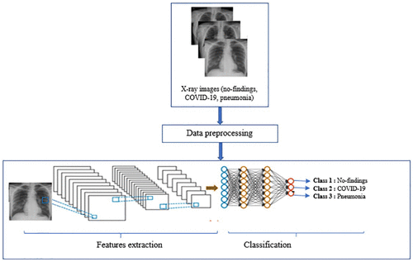

Fig 2 shows the classification of covid disease from the set of sample x-ray images

**X-ray image Dataset**

In this work, we used around 4200 chest X-ray images of COVID-19 obtained from the open-source GitHub repository, shared by Dr. Joseph Cohen,and the Covid-19 Radiography dataset. We also used the ChestX-ray8 database on no-findings and pneumonia images.

Below figure 3.2 shows some examples of chest X-ray images from prepared dataset:

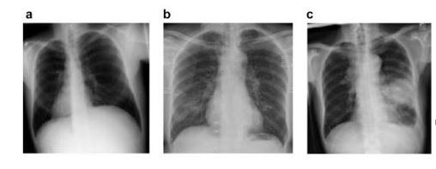

(a) Chest X-ray image of Normal patient

(b) Chest X-ray image of COVID-19 patient

(c)Chest X-ray image of Normal patient

**VII CONCLUSION**

This project focuses mainly on enhancing communication between the Patient and Doctor. It also helps in COVID prediction with chest X-ray scan and Electronic medical records system to manage the health records of the patient**.**

**VIII REFERENCES**

1. J. Latif, C. Xiao, S. Tu, S. U. Rehman, A. Imran and A. Bilal, "Implementation and Use of Disease Diagnosis Systems for Electronic Medical Records Based on Machine Learning: A Complete Review,“ IEEE Access, vol. 8, pp. 150489-150513, 2020.

2. Y. Sun and D. Zhang, ‘‘Diagnosis and analysis of diabetic retinopathy based on electronic health records,’’ IEEE Access, vol. 7, pp. 86115–86120, 2019.

3. T. S. Brisimi, T. Xu, T. Wang, W. Dai, W. G. Adams, and I. C. Paschalidis, ‘‘Predicting chronic disease hospitalizations from electronic health records: An interpretable classification approach,’’ Proc.IEEE, vol. 106, no. 4, pp. 690–707, Apr. 2018.

4. M. Alodadi, ‘‘Radiology clinical notes mining using weighted association rules,’’ in Proc. IEEE Int. Conf. Healthcare Informat. (ICHI), Aug. 2017, pp. 325.

5. E. F. Ohata et al., "Automatic detection of COVID-19 infection using chest X-ray images through transfer learning," in IEEE/CAA Journal of Automatica Sinica, vol. 8, no. 1, pp. 239-248, January 2021.

6. A. Narin, C. Kaya, and Z. Pamuk, “Automatic detection of an corona virus disease (covid-19) using X-ray images and convolutional neural networks, arXiv: 2003.10849, 2020